Bahria University,

Karachi Campus



Course: CSL 220 Database management systems Lab

Term: Spring 2022, Class: BSE- 4(B)

Submitted By:

Abdul Quddos 69984

(Name) (Reg. No.)

Submitted To:

Mam Laraib Siddique/Engr. Ayesha Khan

Signed Remarks: Score:

INDEX

|  |  |  |  |  |
| --- | --- | --- | --- | --- |
| SNO | DATE | LAB NO | LAB OBJECTIVE | SIGN |
|  |  |  |  |  |
|  |  |  |  |  |
|  |  |  |  |  |
|  |  |  |  |  |
|  |  |  |  |  |
|  |  |  |  |  |
|  |  |  |  |  |
|  |  |  |  |  |
|  |  |  |  |  |
|  |  |  |  |  |
|  |  |  |  |  |
|  |  |  |  |  |
|  |  |  |  |  |
|  |  |  |  |  |
|  |  |  |  |  |
|  |  |  |  |  |
|  |  |  |  |  |
|  |  |  |  |  |
|  |  |  |  |  |
|  |  |  |  |  |

Bahria University,

Karachi Campus



LAB EXPERIMENT NO.

1

LIST OF TASKS

|  |  |
| --- | --- |
| TASK NO | OBJECTIVE |
|  |  |
|  |  |
|  |  |
|  |  |
|  |  |
|  |  |
|  |  |
|  |  |
|  |  |
|  |  |

Submitted On:

(Date: //)

**LAB # 01**

**Task # 01:**

1. **Create basic calculator application on Console Application that perform basic arithmetic operations like(add,subtract,multiply,divide ….)**

**Solution:**

Console.WriteLine("This is the calculator!");

Console.WriteLine("Enter the two numbers which you want to perform arithmetic operations!");

int b = Convert.ToInt32(Console.ReadLine());

int c = Convert.ToInt32(Console.ReadLine());

Console.WriteLine("Enter the operation which you want to do?");

Console.WriteLine("1.Addition");

Console.WriteLine("2.Subtraction");

Console.WriteLine("3.Multiply");

Console.WriteLine("4.Division");

int a = Convert.ToInt32(Console.ReadLine());

switch (a)

{

case 1:

Console.WriteLine("The addition of two numbers is = " + (b + c));

break;

case 2:

Console.WriteLine("The subtraction of two numbers is = " + (b - c));

break;

case 3:

Console.WriteLine("The multiplication of two numbers is = " + (b * c));

break;

case 4:

Console.WriteLine("The division of two numbers is = " + (b / c));

break;

}

**Output:**

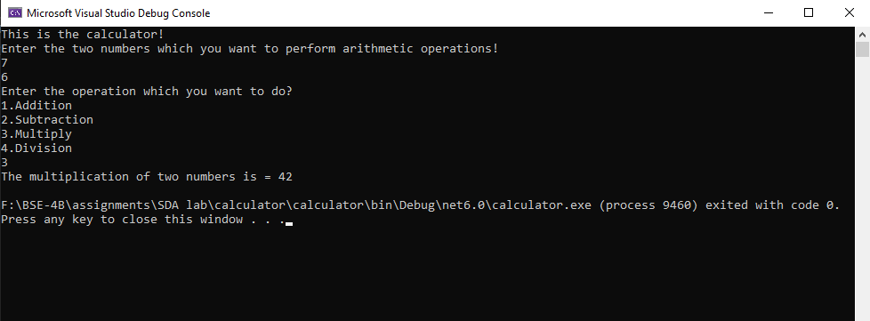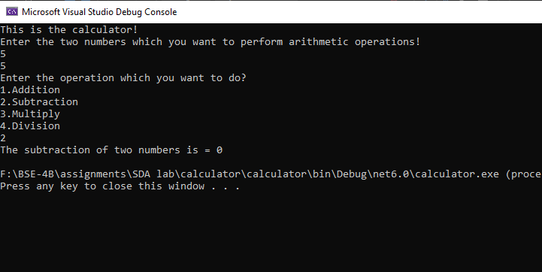

**Task2:**